Algorithm
1) Create a set sptSet (shortest path tree set) that keeps track of vertices included in the shortest-path tree, i.e., whose minimum distance from the source is calculated and finalized. Initially, this set is empty.
2) Assign a distance value to all vertices in the input graph. Initialize all distance values as INFINITE. Assign distance value as 0 for the source vertex so that it is picked first.
3) While sptSet doesn’t include all vertices
….a) Pick a vertex u which is not there in sptSet and has a minimum distance value.
….b) Include u to sptSet.
….c) Update distance value of all adjacent vertices of u. To update the distance values, iterate through all adjacent vertices. For every adjacent vertex v, if the sum of distance value of u (from source) and weight of edge u-v, is less than the distance value of v, then update the distance value of v.

Let us understand with the following example:
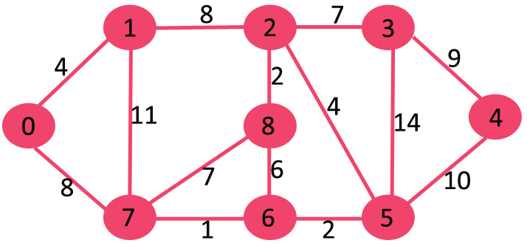

The set sptSet is initially empty and distances assigned to vertices are {0, INF, INF, INF, INF, INF, INF, INF} where INF indicates infinite. Now pick the vertex with a minimum distance value. The vertex 0 is picked, include it in sptSet. So sptSet becomes {0}. After including 0 to sptSet, update distance values of its adjacent vertices. Adjacent vertices of 0 are 1 and 7. The distance values of 1 and 7 are updated as 4 and 8. The following subgraph shows vertices and their distance values, only the vertices with finite distance values are shown. The vertices included in SPT are shown in green colour.
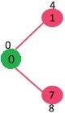
Pick the vertex with minimum distance value and not already included in SPT (not in sptSET). The vertex 1 is picked and added to sptSet. So sptSet now becomes {0, 1}. Update the distance values of adjacent vertices of 1. The distance value of vertex 2 becomes 12.
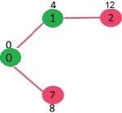
Pick the vertex with minimum distance value and not already included in SPT (not in sptSET). Vertex 7 is picked. So sptSet now becomes {0, 1, 7}. Update the distance values of adjacent vertices of 7. The distance value of vertex 6 and 8 becomes finite (15 and 9 respectively).
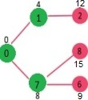
Pick the vertex with minimum distance value and not already included in SPT (not in sptSET). Vertex 6 is picked. So sptSet now becomes {0, 1, 7, 6}. Update the distance values of adjacent vertices of 6. The distance value of vertex 5 and 8 are updated.
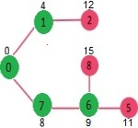
We repeat the above steps until sptSet includes all vertices of the given graph. Finally, we get the following Shortest Path Tree (SPT).
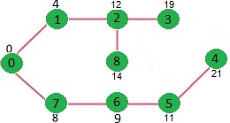
We use a boolean array sptSet[] to represent the set of vertices included in SPT. If a value sptSet[v] is true, then vertex v is included in SPT, otherwise not. Array dist[] is used to store the shortest distance values of all vertices.
- C++
- C
- Java
- Python
- C#
- Javascript
// A C++ program for Dijkstra's single source shortest path algorithm.
// The program is for adjacency matrix representation of the graph
#include <iostream>
using namespace std;
#include <limits.h>

// Number of vertices in the graph
#define V 9

// A utility function to find the vertex with minimum distance value, from
// the set of vertices not yet included in shortest path tree
int minDistance(int dist[], bool sptSet[])
{

// Initialize min value
int min = INT_MAX, min_index;

for (int v = 0; v < V; v++)
if (sptSet[v] == false && dist[v] <= min)
min = dist[v], min_index = v;

return min_index;
}

// A utility function to print the constructed distance array
void printSolution(int dist[])
{
cout <<"Vertex \t Distance from Source" << endl;
for (int i = 0; i < V; i++)
cout << i << " \t\t"<<dist[i]<< endl;
}

// Function that implements Dijkstra's single source shortest path algorithm
// for a graph represented using adjacency matrix representation
void dijkstra(int graph[V][V], int src)
{
int dist[V]; // The output array. dist[i] will hold the shortest
// distance from src to i

bool sptSet[V]; // sptSet[i] will be true if vertex i is included in shortest
// path tree or shortest distance from src to i is finalized

// Initialize all distances as INFINITE and stpSet[] as false
for (int i = 0; i < V; i++)
dist[i] = INT_MAX, sptSet[i] = false;

// Distance of source vertex from itself is always 0
dist[src] = 0;

// Find shortest path for all vertices
for (int count = 0; count < V - 1; count++) {
// Pick the minimum distance vertex from the set of vertices not
// yet processed. u is always equal to src in the first iteration.
int u = minDistance(dist, sptSet);

// Mark the picked vertex as processed
sptSet[u] = true;

// Update dist value of the adjacent vertices of the picked vertex.
for (int v = 0; v < V; v++)

// Update dist[v] only if is not in sptSet, there is an edge from
// u to v, and total weight of path from src to v through u is
// smaller than current value of dist[v]
if (!sptSet[v] && graph[u][v] && dist[u] != INT_MAX
&& dist[u] + graph[u][v] < dist[v])
dist[v] = dist[u] + graph[u][v];
}

// print the constructed distance array
printSolution(dist);
}

// driver program to test above function
int main()
{

/* Let us create the example graph discussed above */
int graph[V][V] = { { 0, 4, 0, 0, 0, 0, 0, 8, 0 },
{ 4, 0, 8, 0, 0, 0, 0, 11, 0 },
{ 0, 8, 0, 7, 0, 4, 0, 0, 2 },
{ 0, 0, 7, 0, 9, 14, 0, 0, 0 },
{ 0, 0, 0, 9, 0, 10, 0, 0, 0 },
{ 0, 0, 4, 14, 10, 0, 2, 0, 0 },
{ 0, 0, 0, 0, 0, 2, 0, 1, 6 },
{ 8, 11, 0, 0, 0, 0, 1, 0, 7 },
{ 0, 0, 2, 0, 0, 0, 6, 7, 0 } };

dijkstra(graph, 0);

return 0;
}

// This code is contributed by shivanisinghss2110
Output:
Vertex Distance from Source
0 0
1 4
2 12
3 19
4 21
5 11
6 9
7 8
8 14
Notes:
1) The code calculates the shortest distance but doesn’t calculate the path information. We can create a parent array, update the parent array when distance is updated (like prim’s implementation) and use it to show the shortest path from source to different vertices.
2) The code is for undirected graphs, the same Dijkstra function can be used for directed graphs also.
3) The code finds the shortest distances from the source to all vertices. If we are interested only in the shortest distance from the source to a single target, we can break the for loop when the picked minimum distance vertex is equal to the target (Step 3.a of the algorithm).
4) Time Complexity of the implementation is O(V^2). If the input graph is represented using adjacency list, it can be reduced to O(E log V) with the help of a binary heap. Please see
Dijkstra’s Algorithm for Adjacency List Representation for more details.
5) Dijkstra’s algorithm doesn’t work for graphs with negative weight cycles. It may give correct results for a graph with negative edges but you must allow a vertex can be visited multiple times and that version will lose its fast time complexity. For graphs with negative weight edges and cycles, Bellman–Ford algorithm can be used, we will soon be discussing it as a separate post.

Suppose a student wants to go from home to school in the shortest possible way. She knows some roads are heavily congested and difficult to use. In Dijkstra's algorithm, this means the edge has a large weight--the shortest path tree found by the algorithm will try to avoid edges with larger weights. If the student looks up directions using a map service, it is likely they may use Dijkstra's algorithm, as well as others.
Find the shortest path from home to school in the following graph:
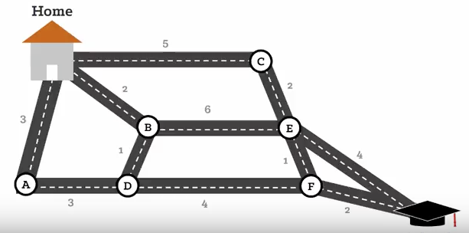
HOME B D F SCHOOL =9

